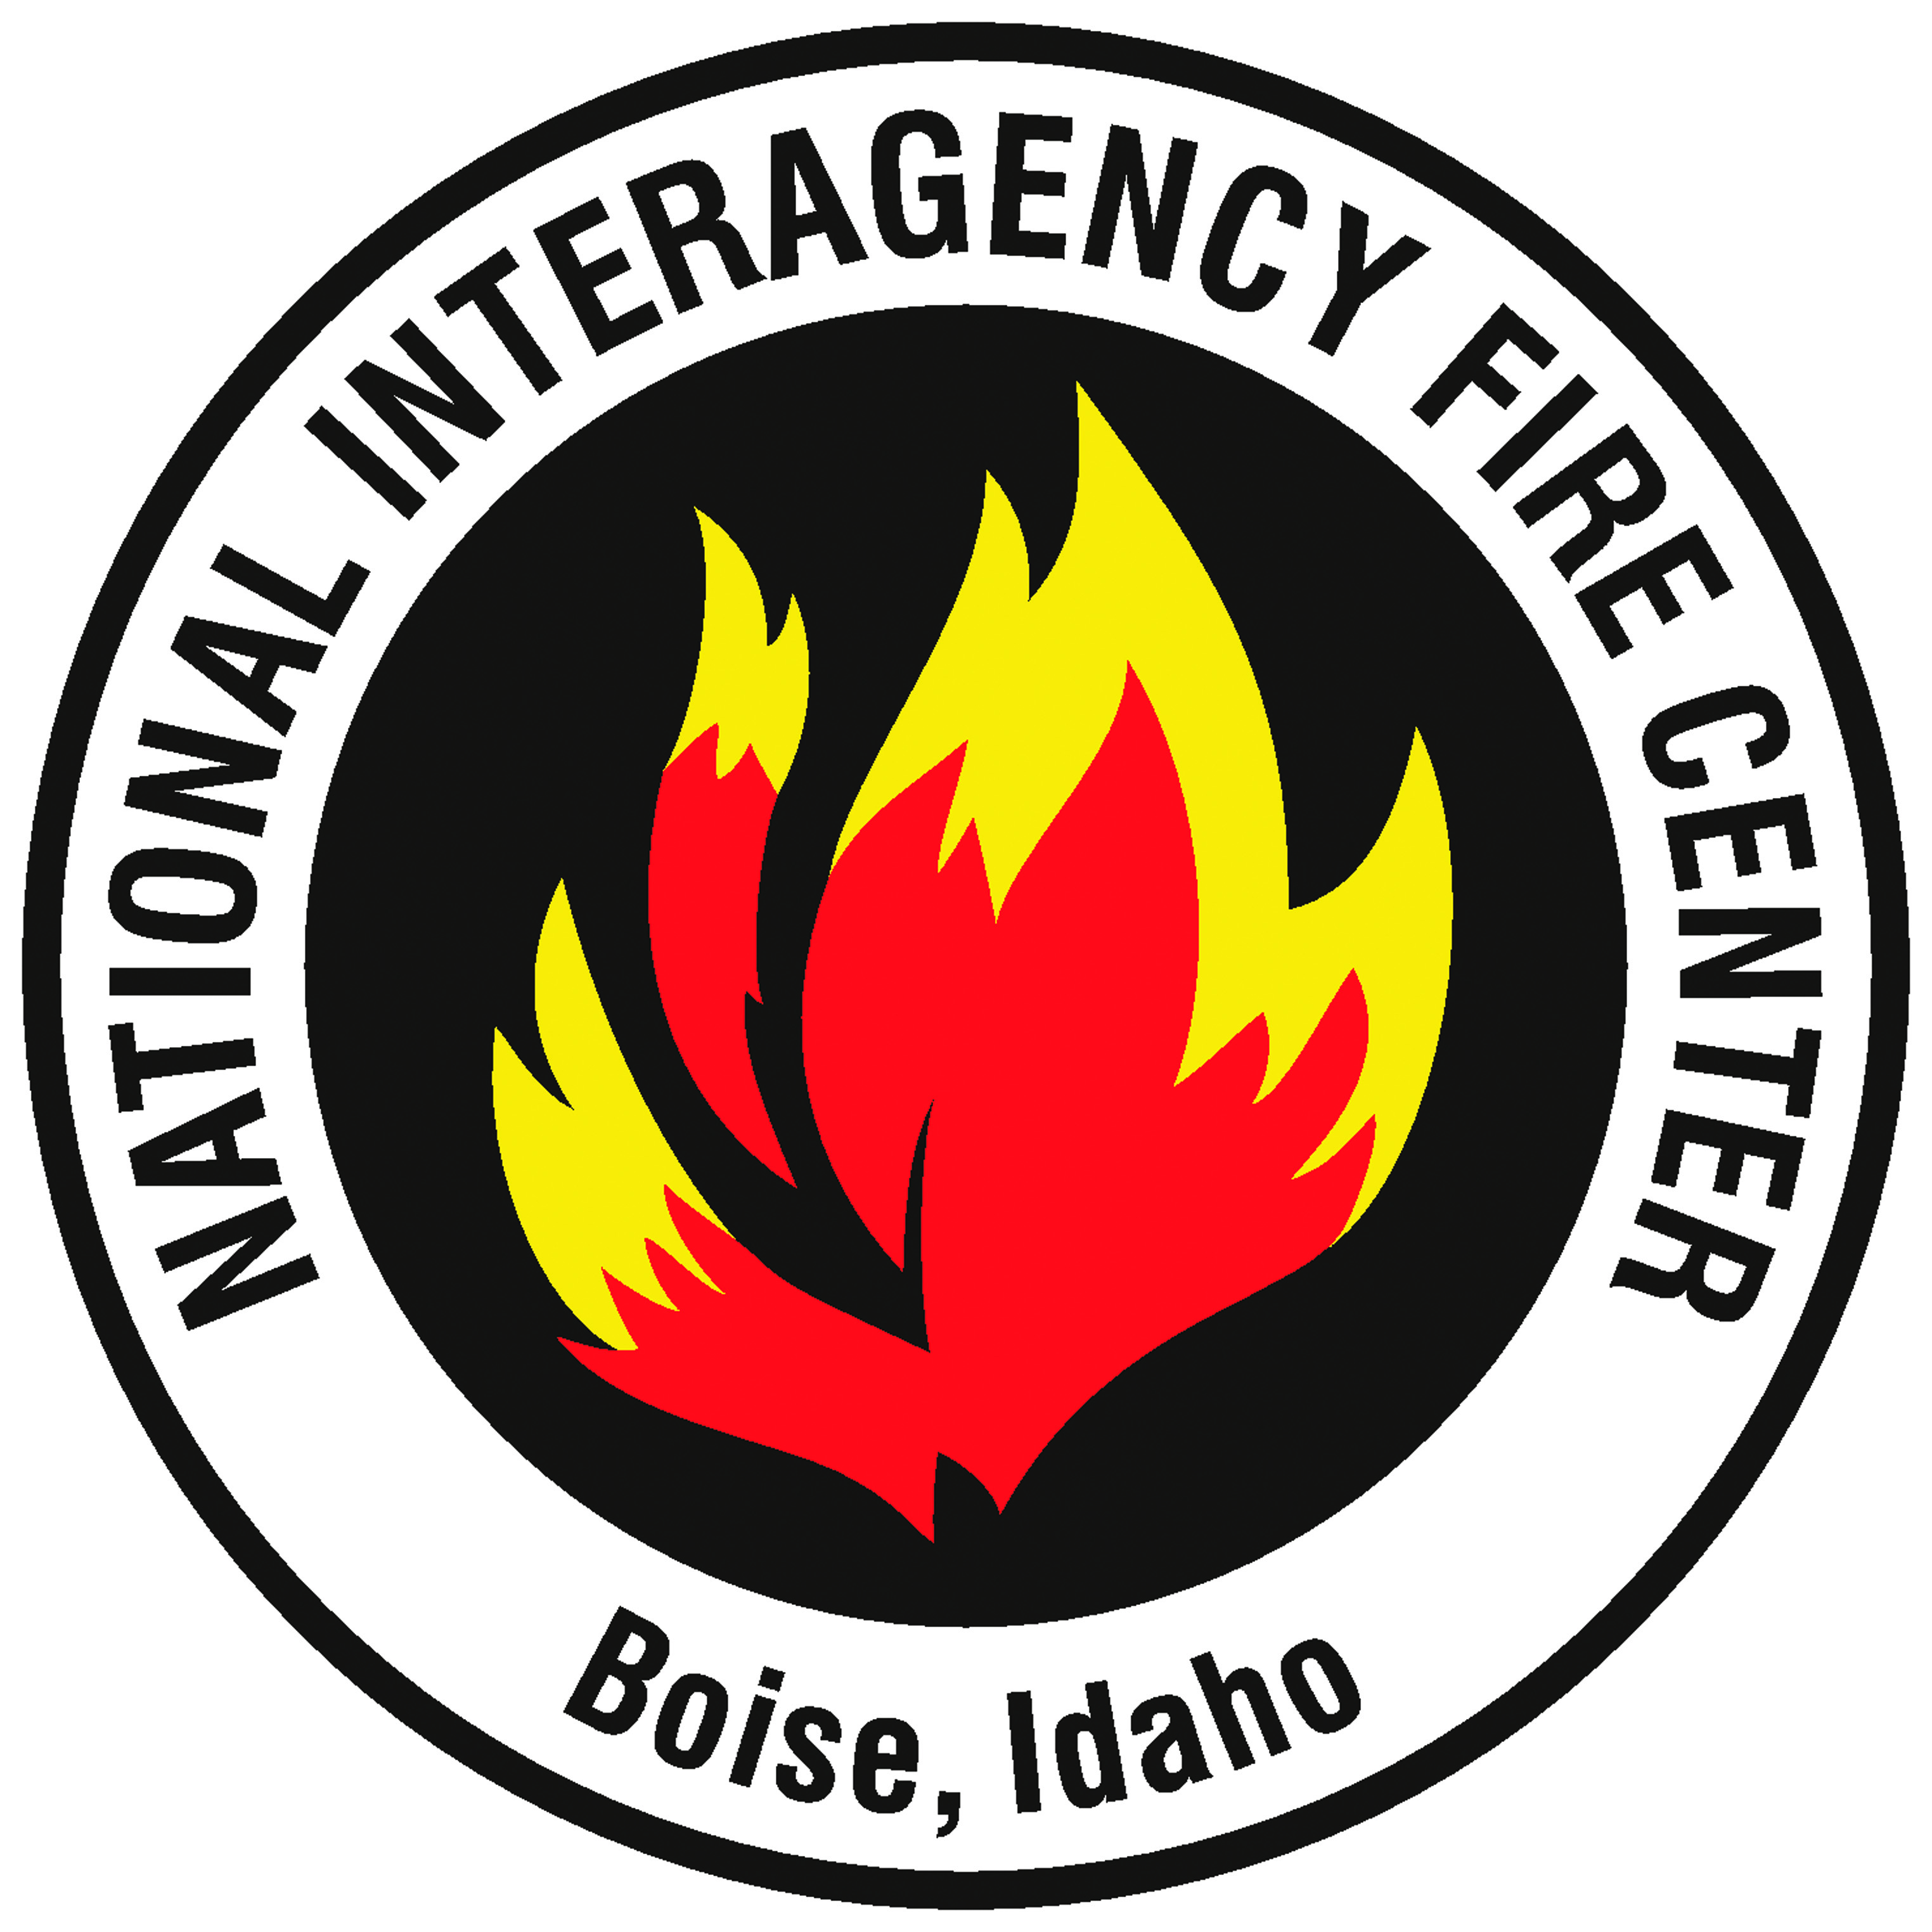

Contact: Ken Frederick
(208) 387-5508
kfrederi@blm.gov
USNORTHCOM Public Affairs Office
(719) 554-6889 (Main Line)

NIFC MOBILIZES ACTIVE DUTY MILITARY PERSONNEL
TO HELP WITH WILDFIRE SUPPRESSION

For the first time since 2006, the National Interagency Fire Center (NIFC) in Boise, Idaho is mobilizing active duty military personnel to serve as firefighters to assist with wildfire suppression efforts. Currently, approximately 95 large wildfires are burning about 1.1 million acres in Oregon, Washington, Idaho, Montana, California, Nevada, and Colorado. The National Preparedness Level is currently at 5, the highest level, indicating a high level of wildfire activity and a high level of commitment of available wildfire suppression assets, such as firefighters, aircraft, and engines. Weather and fuel conditions are predicted to continue to be conducive to wildfire ignitions and spread for the next several weeks.
The National Multi-Agency Coordinating Group (NMAC) at NIFC requested the Department of Defense (DOD) to provide 200 active duty military personnel to assist with firefighting efforts. The DOD has approved the request and identified the 17th Field Artillery Brigade, 7th Infantry Division, Army located at Joint Base Lewis-McChord (JBLM) in Washington to provide the active duty military personnel. The Soldiers will be organized into ten crews of 20 persons each, all of which will be sent to the same wildfire, which is in the process of being identified.
“We are committed to continuing to do everything we can to provide the firefighters, aircraft, engines, and other wildfire suppression assets that Incident Commanders need to protect lives, property, and valuable natural and cultural resources to suppress the most challenging wildfires we’ve experienced in several years,” said Aitor Bidaburu, Chair of NMAC. “The U.S. military has been a key partner in wildland firefighting for decades and we greatly appreciate their willingness to provide us with Soldiers to serve as firefighters as well as C-130s equipped with Modular Airborne Fire Fighting Systems (MAFFS) to serve as large air tankers to help with wildfire suppression efforts.”
The Soldiers will be outfitted with wildland fire Personal Protective Equipment (PPE) and all of the other gear they will need to serve as wildland firefighters. They will be trained by wildland fire agency personnel, including the Bureau of Land Management Vegas Valley Crew comprised entirely of military veterans, at JBLM beginning this Wednesday, August 19th. The training is expected to conclude by Saturday, August 22nd, and the Soldiers are expected to begin working on a wildfire on Sunday, August 23rd.
The training will consist of one day of classroom training at JBLM and one to two days of field training at the wildfire that the Soldiers will be assigned to. During classroom training, Soldiers will learn about a variety of topics related to wildfire suppression including fire terminology, fire behavior, and fireline safety. During field training, Soldiers will receive instruction in fire suppression methods and procedures, including Watch Out Situations and Standard Firefighting Orders; Personal Protective Equipment; and use, transportation, and maintenance of wildfire suppression tools.
The U.S. military has been a key partner in wildland firefighting for decades, providing personnel to serve as wildland firefighters as well as C-130s equipped with Modular Airborne Fire Fighting Systems (MAFFS) to serve as large airtankers. Four military C-130s equipped with MAFFS are currently mobilized and operating from McClellan Airtanker Base in California.
Since 1987, active duty military personnel have been mobilized to serve as wildland firefighters a total of 35 times. The last time that active duty military personnel were mobilized to serve as wildland firefighters was in 2006 when a battalion from JBLM was mobilized to work on the Tripod Complex Fires on the Okanogan-Wenatchee National Forest in Washington. Currently, several states – including California, Washington, and Oregon – have mobilized National Guard personnel to serve as wildland firefighters and helicopters to assist with wildfire suppression efforts.
###

